User app - ANDROID BUG

======================

1. OTP page - enter 3 times wrong otp - after 3rd attempt why it is going back to login and continue page - it should stay and allow to click resend - Video send to Anil - Since OCT 1
2. Why reset password is not working for social login ? - Since AUG 21

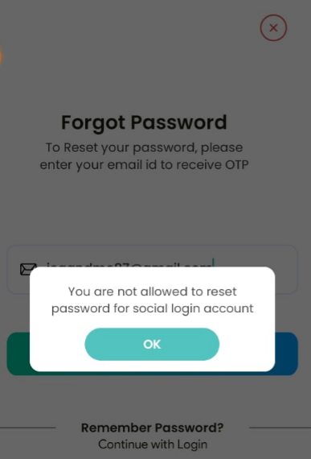

1. Edit profile - Under Country it is showing Emirates - click country and choose any one why emirates is changed to city ? Since OCT 1

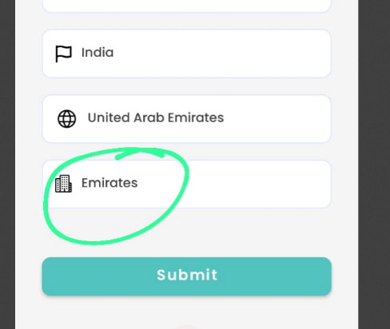 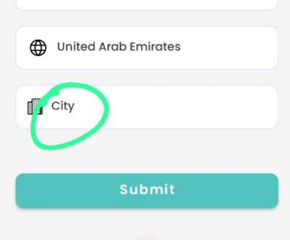

1. Rewards page - Expiring soon why expire on is showing twice and why redeemed is showing under expiring soon ? Since AUG 13

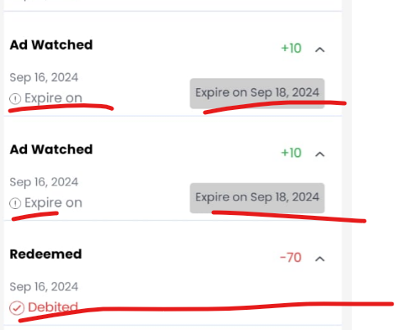

1. Rewards page - your earning points is showing -50 Since OCT 1

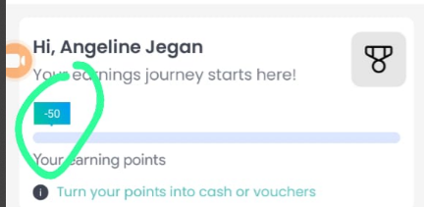

1. Create new voucher why it is adding two time ? Since SEP 10

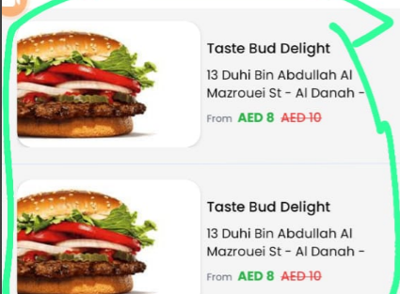

1. My Referral page - icon changes Since SEP 11

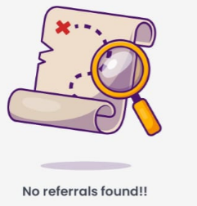

1. Only for Amount type show From AED 8 ( this is what we discuss in meeting ) & from is very tiny increase the size Since SEP 25
2. Offer details - enter 5 Qty - redeem 4 and 1 is not redeemed  - go to coupons page - in All show USED coupon success also it is showing only UNUSED Since SEP 25
3. Coupons page - remove number from used and unused Since OCT 1

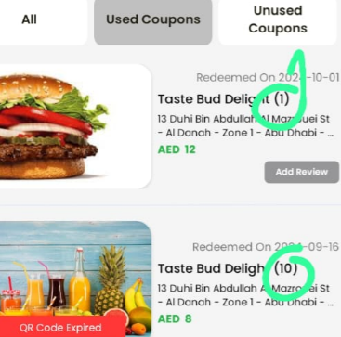

1. Where is the tag for old offers? Video send to Anil - Since SEP16
2. Category - click event & ticket - it is not showing the data Since SEP13

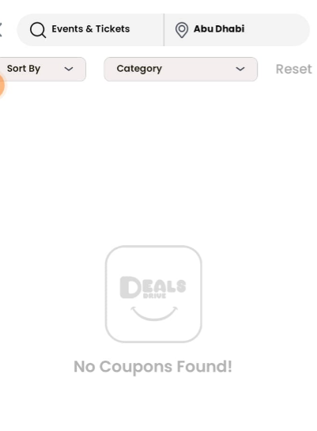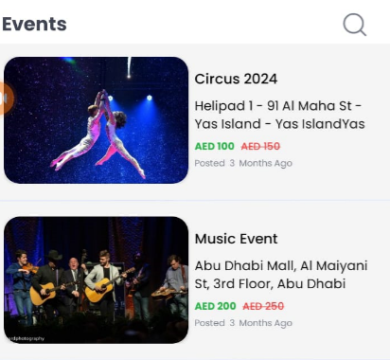

1. Edit profile - why it is not allowing me to change the email ? Since OCT 1
2. In banner - click search - why newly added coupon is not showing at the first? Since Sep 13
3. Give review for any offer - why other users don’t have access to see the reviews and how provider will know about the customer review & how they will replay ?

Since May 13

1. Offer details - once all qr code is redeemed - review is missing.Since sep 13
2. Top banner has 3images  - by manually swipe left to right - it is not workingSince Aug 13
3. From banner click map - search dubai mall - click view deals - from outlet coupon click search why it is showing abu dhabi offers ?Since sep 13
4. [Jaashaesme@gmail.com](mailto:Jaashaesme@gmail.com) is deactivated accout - Click forget password - enter this email id you l receive a OTP enter that and enter password and confirm password - Show success msg and from login page enter that num and login throws error Since sep 16

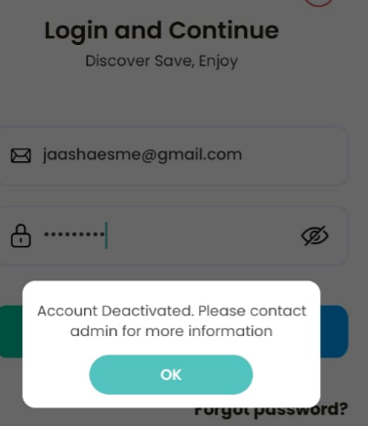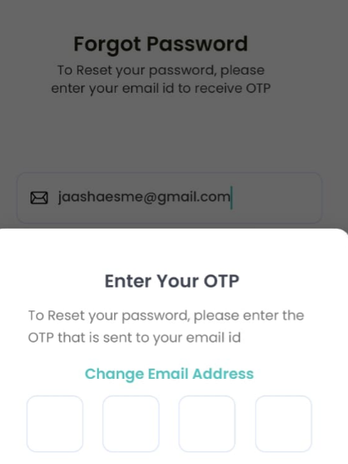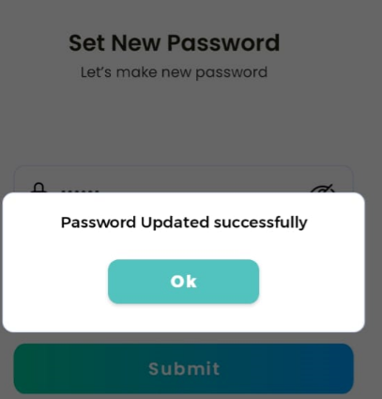

1. Don’t don’t show QR code expried for used coupons Since sep 16

User app - ios BUGS

====================

1. Create a account - OTP verify page - enter wrong otp 3 times - after 3rd time click resend the code - previously entered code should be cleared Since OCT 1

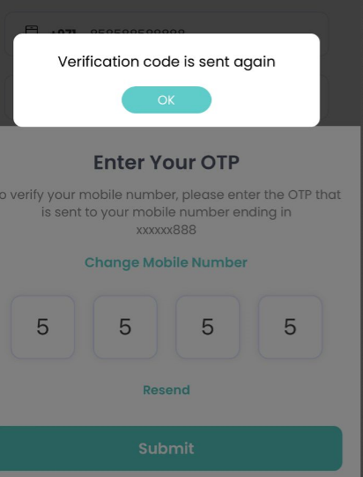

1. In banner & in account page - Letter G is hiding Since OCT 1

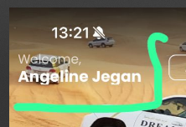 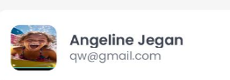

1. Edit profile - why it is not allowing me to change the email ? Since OCT 1
2. Min required points to withdraw is 10 - I tried to withdraw for 6.82 - click redeem points why success msg is showing ? Since OCT 1

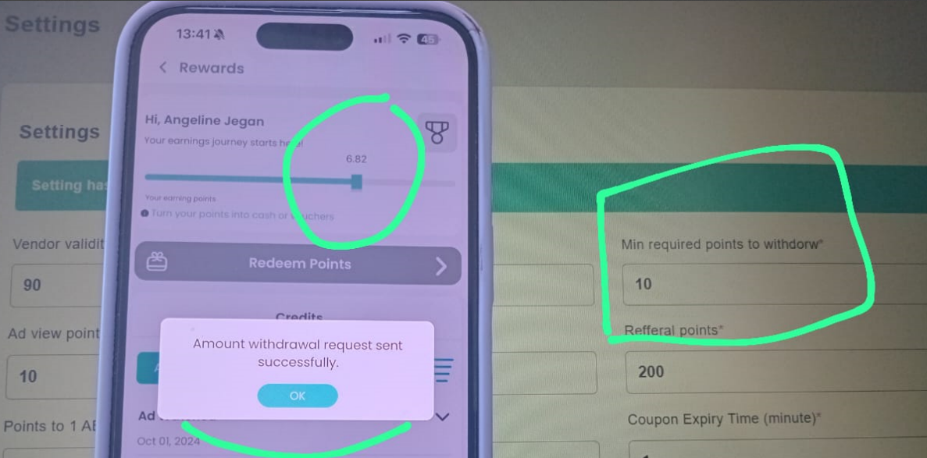

1. Why reset password is not working for social login ? Since AUG 21
2. Rewards page - Expiring soon why Expired is showing , expire on is showing twice, why redeemed is showing under expiring soon ? & date is missing Since AUG 13

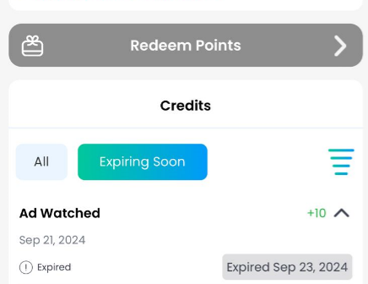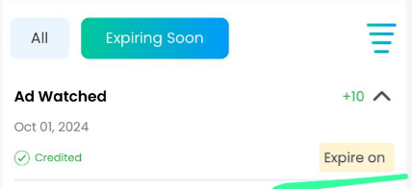

1. Create new voucher why it is adding two time ? Since SEP 10



1. Only for Amount type show From AED 8 ( this is what we discuss in meeting ) & from is very tiny increase the size Since SEP 25
2. Go to any offer details - enter 10 qty watch ad - redeem all QR code - go to the same offer and enter 2 qty watch ad - now go to coupons page - in All option show separate offer for already redeemed and for another offer Since Oct 1
3. Account page - click referral code copy - why pop up is showing ? - show toast msg Since SEP 25
4. Abu Dhabi location - Click banner for Nemo - it’s a dubai offer - it I redirect from banner it should change the location and show the offers Since Oct 1
5. Where is the tag for old offers? Since SEP16
6. Category - click event & ticket - it is not showing the data Since SEP13



Give review for any offer - why other users don’t have access to see the reviews and how provider will know about the customer review & how they will replay ? Since May 13

1. Offer details - Copy Qr code - why pop up is showing - show toast msg Since SEP 25
2. From banner click map - search dubai mall - click view deals - from outlet coupon click search why it is showing abu dhabi offers ? Since sep 13
3. Coupon page - Add review - enter comment & star - click submit - why pop up msg is showing show toast msg Since SEP 25
4. 21. Don’t show QR code expried for used couponsSince sep 16
5. While using it keepon logout - Since Sep 14
6. [Jaashaesme@gmail.com](mailto:Jaashaesme@gmail.com) is deactivated accout - Click forget password - enter this email id you l receive a OTP enter that and enter password and confirm password - throws error msg Since sep 16

PROVIDER

=========

1. Notification - icon changes Since Oct 1

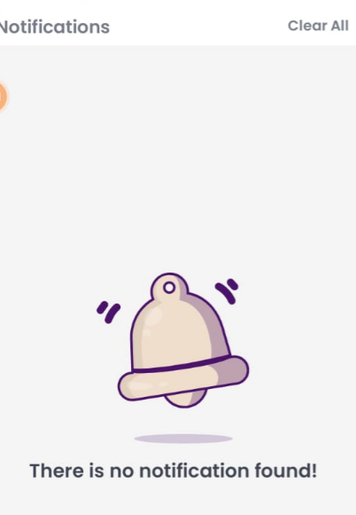

ADMIN

=========

1.UPTO auto calculation is not working in admin pannel - Since SEP 11